Elaboration Phase Specification

CIS 320-02

Group A

Michelle Green, Aquazia Hamler, Devon Johnson, Justin Laramore, Noah Leon

Table of Contents

System Requirements 2

Use Case Descriptions Use Case Diagrams, and Sequence Diagrams 6

Trace Matrix 65

Class Diagram 67

Database Diagram 67

Database Definitions 68

User Interface Navigation Diagram and Screen Layouts 94

Gantt Chart 100

Physical Architecture Design 102

Design Procedures for Security Concerns and Non-Functional Requirements 102

Elaboration Phase Prototypes 103

# System Requirements

**Functional Requirements**

Home Page Requirements

ID: SR001 – The home page will allow information to be edited.

ID: SR002 – The home page will allow general stats posts to be created.

ID: SR003 – The homepage will allow general stats post to be edited.

ID: SR004 – The homepage will allow general stats to be deleted.

Game Page Requirements

ID: SR005 – The game page will allow game stats to be edited.

ID: SR006 – The game page will allow game information to be created.

ID: SR007 – The game page will allow game information to be edited.

ID: SR008 – The game page will allow game information to be reviewed.

ID: SR009 – The game page will allow game information to be deleted.

Player Page Requirements

ID: SR010 – The Player page will allow player personal information to be edited.

ID: SR011 – The Player page will allow players individual stats to be inputted.

ID: SR012 – The player page will allow players profiles to be created.

ID: SR013 – The player page will allow players profiles to be edited.

ID: SR014 – The player page will allow players profiles to be deleted.

ID: SR015 – The player page will allow players individual stats to be created.

ID: SR016 – The player page will allow players individual stats to be edited.

ID: SR017 – The player page will allow players individual stats to be deleted.

ID: SR018 – The player page will allow players portraits to be uploaded.

ID: SR019 – The player page will allow players portraits to be removed.

Team Stats Page Requirements

ID: SR020 – The Team Stats page will allow team information to be edited.

ID: SR021 – The Team Stats page will allow team stats to be created.

ID: SR022 – The Team Stats page will allow team stats to be edited.

ID: SR023 – The Team Stats page will allow teams stats to be deleted.

Leaderboards Page Requirements

ID: SR024 – The leaderboards page will allow information to be edited.

ID: SR025 – The leaderboards page will allow players stats to be viewed.

Nutrition Page Requirements

ID: SR026 – The nutrition page will allow information to be edited.

ID: SR027 – The nutrition page will allow players nutrition info to be created.

ID: SR028 – The nutrition page will allow players nutrition info to be edited.

ID: SR029 – The nutrition page will allow players nutrition info to be deleted.

ID: SR030 – The nutrition page will allow players nutrition issues to be input.

ID: SR031 – The nutrition page will allow players nutrition issues to be removed.

Health Page Requirements

ID: SR032 – The health page will allow information to be created.

ID: SR033 – The health page will allow information to be edited.

ID: SR034 – The health page will allow players medical records to be uploaded.

ID: SR035 – The health page will allow players medical records to be updated.

ID: SR036 – The health page will allow players medical records to be removed.

Practice Page Requirements

ID: SR037 – The practice page will allow information to be edited.

ID: SR038 – The practice page will allow practice information to be uploaded.

ID: SR039 – The practice page will allow practice information to be updated.

ID: SR040 – The practice page will allow practice information to be reviewed.

ID: SR041 – The practice page will allow practice information to be removed.

**Non-functional Requirements**

Performance Requirements

ID: SR042 – The website will load quickly.

ID: SR043 – The website will run with no errors.

ID: SR044 – The website will be updated as needed.

Security Requirements

ID: SR045 – The content management system will backup automatically

ID: SR046 – The content management system will authenticate the web administrator

Availability Requirements

ID: SR047 – The website will be always accessible.

ID: SR048 – The website will be compatible with most web browsers.

ID: SR049 – The website will be compatible with most devices.

ID: SR050 – The website will adhere to W3C web accessibility standards.

# Use Case Descriptions Use Case Diagrams, and Sequence Diagrams

**Use Case 1:** Edit Website Info

Narrative: An administrator can edit information on the website as a whole.

**Use Case 2:** Create General Stats **Use Case 3:** Edit General Stats **Use Case 4:** Delete General Stats

Narrative: An administrator with the proper security permissions is able to create, edit, and delete general statistics.

**Use Case 5:** Edit Game Stats **Use Case 6:** Create Game Info **Use Case 7:** Edit Game Info **Use Case 8:** Review Game Info **Use Case 9:** Delete Game Info

Narrative: An administrator with the proper security permissions is able to create, edit, review, and delete game information, as well as edit game statistics.

Cases 1-4 (General stats)

|  |  |  |
| --- | --- | --- |
| Use Case Name: Website Info Edit | ID: 0 | Importance Level: High |
| Primary Actor: Administrator | | Use Case Type: Detail, Essential |
| Stakeholders and Interests:  Administrator – Wants to edit information on website  Website - tool used to collect players information  Stats Tracker – Tracks stats of team, and individual players | | |
| Brief Description: This use case describes how information on the website will be edited. | | |
| Trigger: Administrator navigates to the edit function of the website.  Type: External | | |
| Relationships:  Association: Administrator, coaches, managers, nutritionists  Include:  Extend  Generalization: | | |
| Normal Flow of Events:   1. The administrator navigates to the edit information function. 2. The administrator edits the information needed. 3. The administrator submits the information. 4. The administrator saves the information and exit’s out of the information edit function. 5. The edited information is displayed to website. | | |
| SubFlows: | | |
| Alternate/Exceptional Flows:  6a. The information isn’t saved. | | |

Risk Level: high

|  |  |  |
| --- | --- | --- |
| Use Case Name: Create General Stats | ID: 02 | Importance Level: High |
| Primary Actor: Administrator | | Use Case Type: Detail, Essential |
| Stakeholders and Interests:  Administrator – wants to add general stats information to the general stats post  Website - tool used to collect general stats  Stats Tracker – Tracks stats of team, and individual players | | |
| Brief Description: This use case describes how general stats of players/team will be posted. | | |
| Trigger: Administrator navigates to the stats function of the website.  Type: External | | |
| Relationships:  Association: Administrator, coaches, managers, nutritionists  Include:  Extend  Generalization: | | |
| Normal Flow of Events:   1. The administrator navigates to the stats function of the website. 2. The administrator edits the information needed. 3. The administrator submits the information. 4. The administrator saves the information and exit’s out of the information stats function. 5. The edited information is displayed to website. | | |
| SubFlows: | | |
| Alternate/Exceptional Flows:  6a. The information isn’t saved. | | |

|  |  |  |
| --- | --- | --- |
| Use Case Name: Edit General Stats | ID: 03 | Importance Level: High |
| Primary Actor: Administrator | | Use Case Type: Detail, Essential |
| Stakeholders and Interests:  Administrator – Wants to edit information on the stats page.  Website - tool used to collect players information  Stats Tracker – Tracks stats of team, and individual players | | |
| Brief Description: This use case describes how information on the stats will be edited. | | |
| Trigger: Administrator navigates to the edit function of the stats page.  Type: External | | |
| Relationships:  Association: Administrator, coaches, managers, nutritionists  Include:  Extend  Generalization: | | |
| Normal Flow of Events:   1. The administrator navigates to the edit information function for the general stats page. 2. The administrator edits the information needed. 3. The administrator submits the information. 4. The administrator saves the information and exit’s out of the information edit function for the general stats page. 5. The edited information is displayed to website. | | |
| SubFlows: | | |
| Alternate/Exceptional Flows:  6a. The information isn’t saved. | | |

|  |  |  |
| --- | --- | --- |
| Use Case Name: Delete General Stats | ID: 04 | Importance Level: High |
| Primary Actor: Administrator | | Use Case Type: Detail, Essential |
| Stakeholders and Interests:  Administrator – Wants to remove information on the website.  Website - tool used to collect players information  Stats Tracker – Tracks stats of team, and individual players | | |
| Brief Description: This use case describes how information on the website will be removed. | | |
| Trigger: Administrator navigates to the remove function of the website.  Type: External | | |
| Relationships:  Association: Administrator, coaches, managers, nutritionists  Include:  Extend  Generalization: | | |
| Normal Flow of Events:   1. The administrator navigates to the remove information function. 2. The administrator removes the information needed. 3. The administrator submits the information. 4. The administrator saves the information and exit’s out of the information remove function. 5. The removed information will no longer be displayed. | | |
| SubFlows: | | |
| Alternate/Exceptional Flows:  6a. The information isn’t saved. | | |
| Use Case Name: Edit Game Stats | ID: 05 | Importance Level: High |
| Primary Actor: Administrator | | Use Case Type: Detail, Essential |
| Stakeholders and Interests:  Administrator – Wants to edit game stats information on website  Website - tool used to collect players information  Stats Tracker – Tracks stats of team, and individual players | | |
| Brief Description: This use case describes how information on the game stats page will be edited. | | |
| Trigger: Administrator navigates to the edit function of the website.  Type: External | | |
| Relationships:  Association: Administrator, coaches, managers, nutritionists  Include:  Extend  Generalization: | | |
| Normal Flow of Events:   1. The administrator navigates to the edit information function for the game stats page. 2. The administrator edits the information needed. 3. The administrator submits the information. 4. The administrator saves the information and exit’s out of the information edit function. 5. The edited information is displayed to website. | | |
| SubFlows: | | |
| Alternate/Exceptional Flows:  6a. The information isn’t saved. | | |

|  |  |  |
| --- | --- | --- |
| Use Case Name: Create Game Info | ID: 06 | Importance Level: High |
| Primary Actor: Administrator | | Use Case Type: Detail, Essential |
| Stakeholders and Interests:  Administrator – Wants to edit information on website  Website - tool used to collect players information  Stats Tracker – Tracks stats of team, and individual players | | |
| Brief Description: This use case describes how information on the game page will be added. | | |
| Trigger: Administrator navigates to the edit function of the website.  Type: External | | |
| Relationships:  Association: Administrator, coaches, managers, nutritionists  Include:  Extend  Generalization: | | |
| Normal Flow of Events:   1. The administrator navigates to the edit information function and adds information about the game to the game page. 2. The administrator edits the information needed. 3. The administrator submits the information. 4. The administrator saves the information and exit’s out of the information edit function. 5. The edited information is displayed to website. | | |
| SubFlows: | | |
| Alternate/Exceptional Flows:  6a. The information isn’t saved. | | |

|  |  |  |
| --- | --- | --- |
| Use Case Name: Edit Game Information | ID: 07 | Importance Level: High |
| Primary Actor: Administrator | | Use Case Type: Detail, Essential |
| Stakeholders and Interests:  Administrator – Wants to edit information on website for the game page  Website - tool used to collect players information  Stats Tracker – Tracks stats of team, and individual players | | |
| Brief Description: This use case describes how information on the game page will be edited. | | |
| Trigger: Administrator navigates to the edit function of the website.  Type: External | | |
| Relationships:  Association: Administrator, coaches, managers, nutritionists  Include:  Extend  Generalization: | | |
| Normal Flow of Events:   1. The administrator navigates to the edit information function. 2. The administrator edits the information needed on the game page. 3. The administrator submits the information. 4. The administrator saves the information and exit’s out of the information edit function. 5. The edited information is displayed to website. | | |
| SubFlows: | | |
| Alternate/Exceptional Flows:  6a. The information isn’t saved. | | |

|  |
| --- |
| **Use Case:** Review Game Info |
| **ID:** 8 |
| **Description:** This use case describes how game information is reviewed |
| **Importance Level:** High |
| **Primary Actor:** Administrator |
| **Trigger:** User navigates to the game information tab. |
| **Type:** External |
| **Basic Flow:**  1. The admin navigates to the game information tab on the website. |
| **Alternative Flows:** |
| **Preconditions:** |
| **Postconditions:** |
| **Special Requirements:** |

|  |
| --- |
| **Use Case:** Delete Game Info |
| **ID:** 9 |
| **Description:** This use case describes how game information is deleted. |
| **Importance Level:** High |
| **Primary Actor:** Administrator |
| **Trigger:** User navigates to the game information tab. |
| **Type:** External |
| **Basic Flow:**  1. The admin navigates to the game information tab on the website.  2. The admin clicks the “Delete Game Info” button to delete the game information.  3. The admin clicks “Ok” on the confirmation pop-up.  4. The game information is deleted. |
| A**lternative Flows:**  4a. The deletion was not processed.  4b. A pop-up message notifies the admin that the deletion was not processed. |
| **Preconditions:** |
| **Postconditions:** |
| **Special Requirements:** |

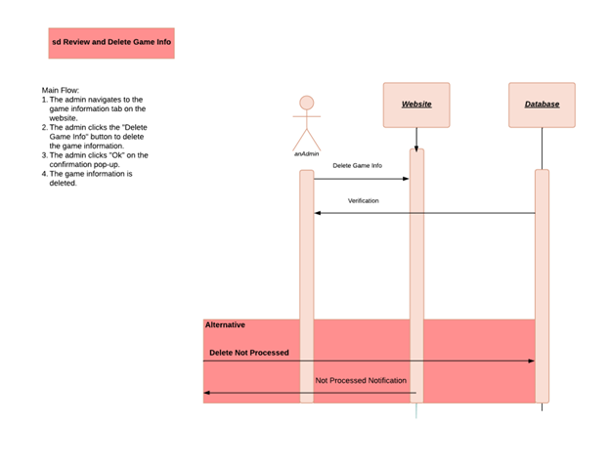

|  |
| --- |
| **Use Case:** Edit Player Information |
| **ID:**10 |
| **Description:** This use case describes that player information can be edited. |
| **Importance Level:** High |
| **Primary Actor:** Administrator |
| **Trigger:** User navigates to the player selection tab. |
| **Type:** External |
| **Basic Flow:**   1. The admin navigates to the player selection tab on the website. 2. The admin selects the “Edit Player Profile” button. 3. The admin edits the necessary information. 4. The admin clicks the “Save” button to save the changes. |
| **Alternative Flows:**  5a. The edit was not processed.  5b. A pop-up notification notifies the admin that the edit was not processed. |
| **Preconditions:** |
| **Postconditions:** |
| **Special Requirements:** |

|  |
| --- |
| **Use Case:** Create Player Profile |
| **ID: 11** |
| **Description:** This use case describes how player profiles can be created. |
| **Importance Level:** High |
| **Primary Actor:** Administrator |
| **Trigger:** User navigates to the player selection tab. |
| **Type:** External |
| **Basic Flow:**   1. The admin navigates to the player selection tab on the website. 2. The admin selected the “Create Player Profile” button. 3. The admin is directed to a template to fill in necessary information. 4. The admin clicks the “Create” button to submit the player profile. 5. The profile and information are entered into the database. |
| **Alternative Flows:**  5a. The creation was not processed.  5b. A pop-up notification notifies the admin that the creation was not processed. |
| **Preconditions:** |
| **Postconditions:** |
| **Special Requirements:** |

|  |
| --- |
| **Use Case:** Edit Player Profile |
| **ID:**12 |
| **Description:** This use case describes how player profiles are edited. |
| **Importance Level:** High |
| **Primary Actor:** Administrator |
| **Trigger:** User navigates to the player selection tab. |
| **Type:** External |
| **Basic Flow:**   1. The admin navigates to the player selection tab on the website. 2. The admin selects the “Edit Player Profile” button. 3. The admin edits the necessary information” 4. The admin clicks the “Save” button to save the changes. |
| **Alternative Flows:**  5a. The edit was not processed.  5b. A pop-up notification notifies the admin that the edit was not processed. |
| **Preconditions:** |
| **Postconditions:** |
| **Special Requirements:** |

**Case 13:** Delete Player Profile

|  |
| --- |
| **Use Case:** Delete Player Profile |
| **ID:** 13 |
| **Description:** This use case describes how player profiles are deleted. |
| **Importance Level:** High |
| **Primary Actor:** Administrator |
| **Trigger:** User navigates to the player selection tab. |
| **Type:** External |
| **Basic Flow:**   1. The admin navigates to the player selection tab on the website. 2. The admin selects the “Edit player Profile” button. 3. The admin clicks the “Delete” button on the profile they want to delete. 4. The admin clicks the “Ok” button on the confirmation pop-up. 5. The profile is deleted. |
| **Alternative Flows:**  5a. The deletion was not processed.  5b. A pop-up notification notifies the admin that the deletion was not processed. |
| **Preconditions:** |
| **Postconditions:** |
| **Special Requirements:** |

Narrative: An administrator with the proper security permissions is able to create, edit, and delete player profiles, as well as edit player information.

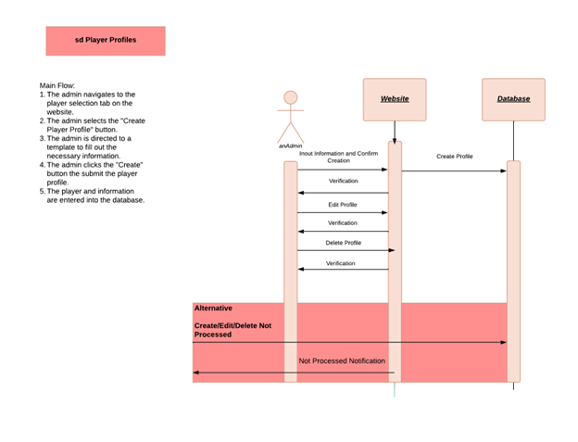

|  |
| --- |
| **Use Case:** Create Player Stats |
| **ID:** 14 |
| **Description:** This use case describes how player stats can be created. |
| **Importance Level:** High |
| **Primary Actor:** Administrator |
| **Trigger:** User navigates to the player selection tab. |
| **Type:** External |
| **Basic Flow:**   1. The admin navigates to the player selection tab on the website. 2. The admin selects a profile. 3. The admin clicks the “Add Stats” button. 4. The admin inputs stats into thr template. 5. The admin clicks the “Save” button to save the changes. |
| **Sub Flows:**  3a. The admin clicks the upload button.  4a. The admin chooses the file they want to upload.  5a. The admin confirms the choice.  6a. The file is converted and input into the profile automatically. |
| **Alternative Flows:**  6a. The changes are not processed.  6b. A pop-up notification notifies the admin that the changes were not processed. |
| **Preconditions:** |
| **Postconditions:** |
| **Special Requirements:** |

|  |
| --- |
| **Use Case:** Edit Player Stats |
| **ID:** 15 |
| **Description:** This use case describes how player stats are edited. |
| **Importance Level:** High |
| **Primary Actor:** Administrator |
| **Trigger:** User navigates to the player selection tab. |
| **Type:** External |
| **Basic Flow:**   1. The admin navigates to the player selection tab on the website. 2. The admin selects a profile. 3. The admin selects the “Edit Player Profile” button. 4. The admin edits the necessary information. 5. The admin clicks the “Save” button to save the changes. |
| **Alternative Flows:**  6a. The edit was not processed.  6b. A pop-up notification notifies the admin that the edit was not processed. |
| **Preconditions:** |
| **Postconditions:** |
| **Special Requirements:** |

|  |
| --- |
| **Use Case:** Delete Player Stats |
| **ID:** 16 |
| **Description:** This use case describes how player stats are deleted. |
| **Importance Level:** High |
| **Primary Actor:** Administrator |
| **Trigger:** User navigates to the player selection tab. |
| **Type:** External |
| **Basic Flow:**   1. The admin navigates to the player selection tab on the website. 2. The admin selects a profile. 3. The admin selects the “Edit Stats” button. 4. The admin removes the information. 5. The admin clicks the “Save” button to save the changes. |
| **Alternative Flows:**  5a. The deletion was not processed.  5b. A pop-up notification notifies the admin that the edit was not processed. |
| **Preconditions:** |
| **Postconditions:** |
| **Special Requirements:** |

Narrative: Narrative: An administrator with the proper security permissions is able to create, edit, and delete player statistics.

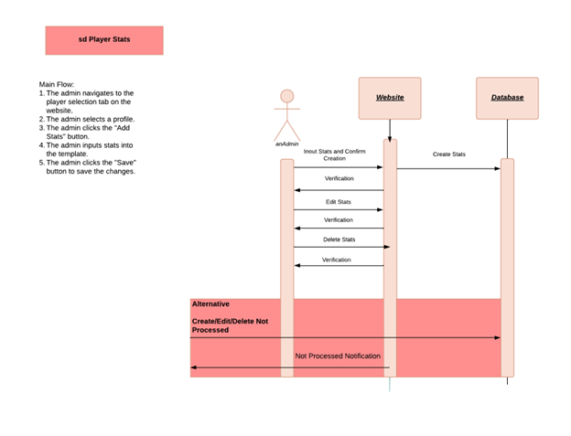

|  |
| --- |
| **Use Case:** Upload Player Portrait |
| **ID:** 17 |
| **Description:** Player's headshots can be uploaded to an individual profile. |
| **Importance Level:** High |
| **Primary Actor:** Administrators |
| **Stakeholder and Interests:** Administration |
| **Trigger:** Player profile is missing a portrait |
| **Basic Flow:**   1. Administrator selects the team tab from the home page. 2. Individual player profile is selected. 3. Headshot is uploaded to the player’s profile |
| **Alternative Flows:**  3a. The headshot is uploaded in the wrong format.  3b. An error message pops up and lists accepted formats.  3c. The headshot is not uploaded |
| **Preconditions:** The team tab is selected once the administrator is logged in. |
| **Postconditions:** The player has a headshot for their profile |
| **Special Requirements:** Administrator must be authorized |

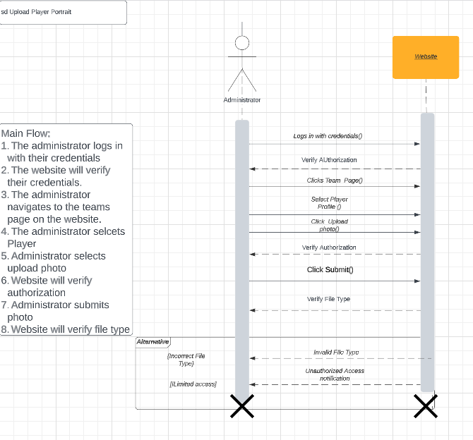

|  |
| --- |
| **Use Case:** Remove Player Portrait |
| **ID:** 18 |
| **Description:** Player's headshots can be removed from an individual profile. |
| **Importance Level:** High |
| **Primary Actor:** Administrators |
| **Stakeholder and Interests:** Administration |
| **Trigger:** Player profile portrait need to be removed |
| **Basic Flow:**   1. Administrator selects the team tab from the home page. 2. Individual player profile is selected. 3. Headshot is removed to the player’s profile |
| **Alternative Flows:** None |
| **Preconditions:** The team tab is selected once the administrator is logged in. |
| **Postconditions:** The player’s headshot is removed from their profile |
| **Special Requirements:** Administrator must have authorization |

Narrative: An administrator with the proper security permissions is able to upload and remove player portraits.

|  |
| --- |
| **Use Case:** Edit Team Info |
| **ID:** 19 |
| **Description:** Information can be edited on the team profile |
| **Importance Level:** High |
| **Primary Actor:** Administrators |
| **Stakeholder and Interests:** Administration |
| **Trigger:** Team information needs to be changed |
| **Basic Flow:**   |  | | --- | | 1. Administrator selects the team page tab from the home page. 2. Administrator selects desired information to edit. |  1. Administrator edits information Administrator edits information |
| **Alternative Flows:**  3a. Administrator does not have authorization  3b. Team information is not updated. |
| **Preconditions:** Team page is selected |
| **Postconditions:** Team information is updated |
| **Special Requirements:** Administrator must have authorization |

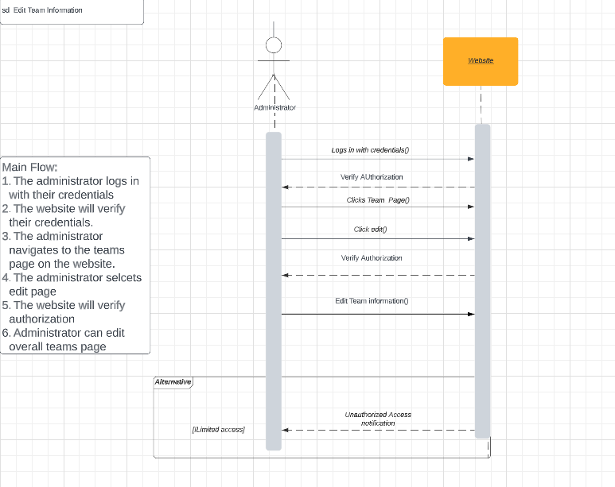

|  |
| --- |
| **Use Case:** Create Team Stats |
| **ID:** 20 |
| **Description:** Team statistics can be created. |
| **Importance Level:** High |
| **Primary Actor:** Administrators |
| **Stakeholder and Interests:** Administration |
| **Trigger:** Team statistics need to be added to webpage |
| **Basic Flow:**   1. Team statistics tab is selected 2. Desired statistics category is selected 3. Administrator inputs statistics 4. Team statistic are created |
| **Alternative Flows:**  3a. Administrator needs proper access.  3b. Team statistics is not created.  4a. Information is inputted in the wrong format.  4b. An error message pops up and lists accepted formats.  4b. Team stats is not created. |
| **Preconditions:** The team tab is selected once the administrator is logged in. |
| **Postconditions:** Team statistics are inputted |
| **Special Requirements:** Administrator must have authorization |

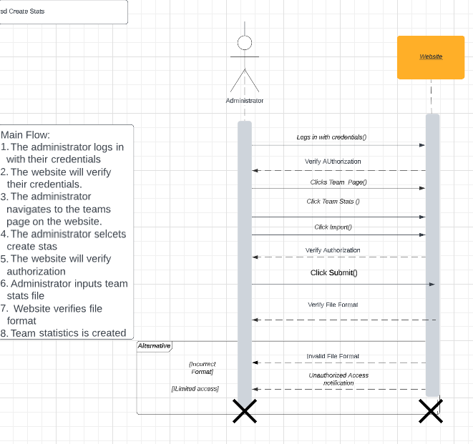

|  |
| --- |
| **Use Case:** Edit Team Stats |
| **ID:** 21 |
| **Description:** Team statistics can be edited. |
| **Importance Level:** High |
| **Primary Actor:** Administrators |
| **Stakeholder and Interests:** Administration |
| **Trigger:** Team statistics need to be updated |
| **Basic Flow:**   1. Team statistics tab is selected 2. Desired statistics category is selected 3. Administrator edits statistics 4. Team statistic are updated |
| **Alternative Flows:**  3a. Administrator needs proper access.  3b. Team statistics is not updated. |
| **Preconditions:** The team tab is selected once the administrator is logged in. |
| **Postconditions:** Team statistics are updated |
| **Special Requirements:** Administrator must have authorization |

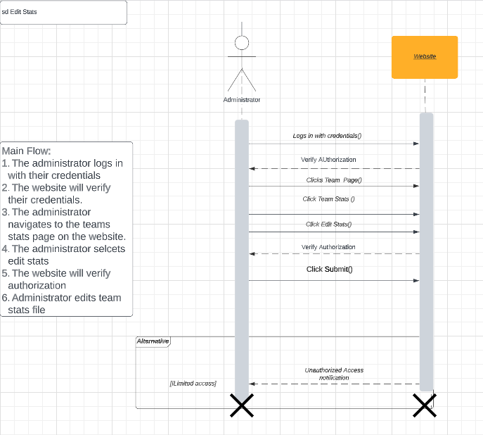

**Use Case 22:** Delete Team Stats

|  |
| --- |
| **Use Case:** Delete Team Stats |
| **ID:** 22 |
| **Description:** Team statistics can be removed. |
| **Importance Level:** High |
| **Primary Actor:** Administrators |
| **Stakeholder and Interests:** Administration |
| **Trigger:** Team statistics need to be removed |
| **Basic Flow:**   1. Team statistics tab is selected 2. Desired statistics category is selected 3. Administrator deletes statistics 4. Team statistic are removed |
| **Alternative Flows:**  3a. Administrator needs proper access.  3b. Team statistics is not removed. |
| **Preconditions:** The team tab is selected once the administrator is logged in. |
| **Postconditions:** Team statistics are removed |
| **Special Requirements:** Administrator must have authorization |

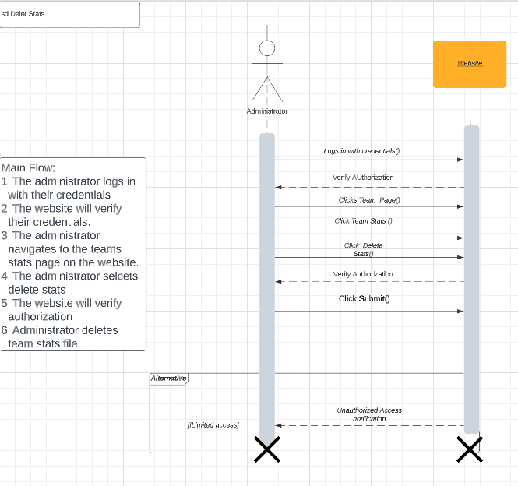

Narrative: An administrator with the proper security permissions is able to create, edit, and delete team statistics, as well as edit team information.

|  |
| --- |
| **Use Case:** Edit Leaderboards |
| **ID:** 23 |
| **Description:** Team leaderboards can be edited |
| **Importance Level:** High |
| **Primary Actor:** Administrators |
| **Stakeholder and Interests:** Administration |
| **Trigger:** Team leaderboards needs to be updated |
| **Basic Flow:**   1. Leaderboard tab is selected 2. Administrator selects desired leaderboard information to be edited 3. Team leaderboard information is updated |
| **Alternative Flows:**  2a. Administrator needs proper access.  2b. Team leaderboard is not updated. |
| **Preconditions:** The team tab is selected once the administrator is logged in. |
| **Postconditions:** Team leaderboard information are inputted |
| **Special Requirements:** Administrator must have authorization |

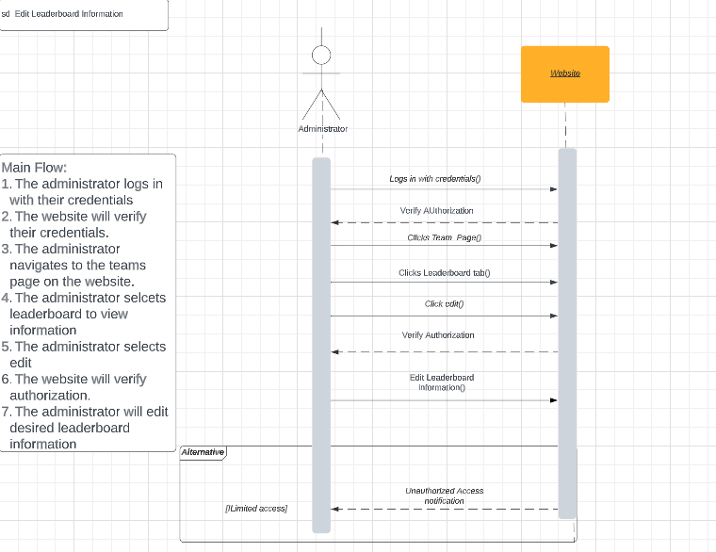

**Use Case 24:** View Leaderboards

|  |
| --- |
| **Use Case:** View Leaderboards |
| **ID:** 24 |
| **Description:** Team statistics can be created. |
| **Importance Level:** High |
| **Primary Actor:** Administrators |
| **Stakeholder and Interests:** Administration |
| **Trigger:** Administrator needs information from leaderboard. |
| **Basic Flow:**   1. Leaderboard tab is selected 2. Administrator selects leaderboard information to be viewed. |
| **Alternative Flows:**  None |
| **Preconditions:** The team tab is selected once the administrator is logged in. |
| **Postconditions:** Leaderboard information is viewed |
| **Special Requirements:** None |

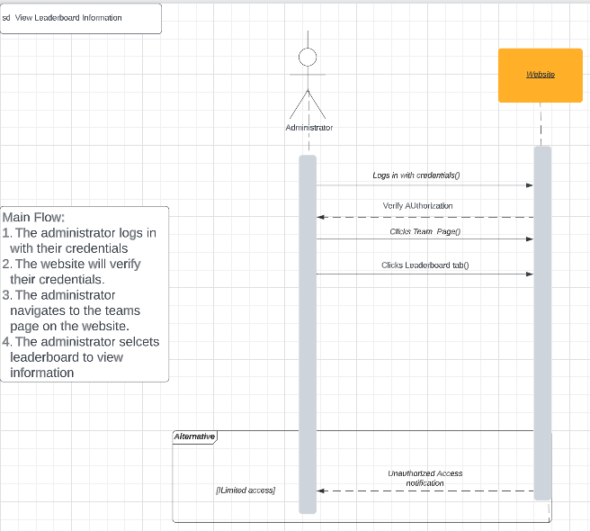

Narrative: An administrator with the proper security permissions can edit and view leaderboards.

|  |
| --- |
| **Use Case:** Create Nutrition Info |
| **ID:** 25 |
| **Description:** The health administrator can create nutrition info for players |
| **Importance Level:** High |
| **Primary Actor:** Administrators |
| **Stakeholder and Interests:** Administration |
| **Trigger:** Administrator needs to create nutrition info for player. |
| **Basic Flow:**   1. Nutrition tab is selected. 2. Administrator clicks the import button. 3. Administrator imports nutrition information. 4. Player nutrition information is created. |
| **Alternative Flows:**  1a. Administrator needs proper access.  1b. Nutrition information is not created.  3a. The information needs to be in the correct format.  3b. An error message pops up and shows the accepted formats.  3c. Player information is not created. |
| **Preconditions:** The nutrition tab is selected once the administrator is logged in. |
| **Postconditions:** Player nutrition information is created |
| **Special Requirements:** Administrator must have proper authorization |

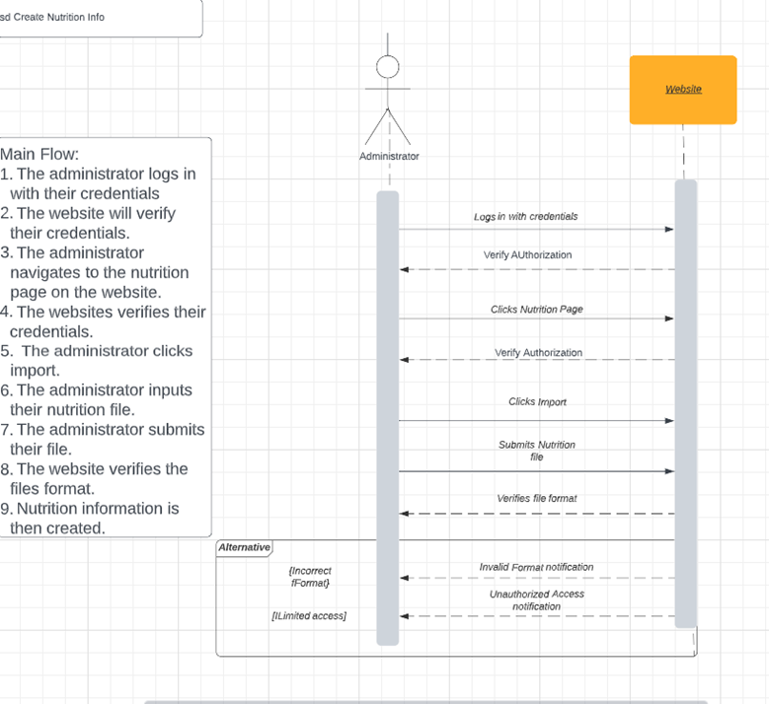

**Use Case 26:** Create Players Nutrition **Use Case 27:** Edit Players Nutrition **Use Case 28:** Remove Players Nutrition **Use Case 29:** Input Nutrition Issues

**Use Case 30:** Remove Nutrition Issues

Narrative: An administrator with the proper security permissions can create nutrition information and player nutrition statistics, edit and remove player nutrition statistics, and input and remove nutrition issues.

|  |
| --- |
| **Use Case:** Create Players Nutrition |
| **ID:** 26 |
| **Description:** Allows a player’s nutrition to be created through the website |
| **Importance Level:** High |
| Primary Actor: Nutritionist |
| **Basic Flow:**   1. This is use case is initiated when the nutritionist wants to create new nutrition information for a specific player. 2. The nutritionist will click the plus sign in a specific players ‘Player Health’ profile. |
| **Alternative Flows:** None |
| **Preconditions:** The nutritionist must have access granted to play nutrition information |
| **Postconditions:** The nutritionist is now able to create player specific nutrition information |
| **Special Requirements:** Can only create information in the form of a spread sheet. |

|  |
| --- |
| **Use Case:** Edit Player Nutrition Information |
| **ID:** 27 |
| **Description:** Allows a players already existing nutrition information to be changed |
| **Importance Level:** High |
| **Primary Actor:** Nutritionist |
| **Trigger:** Nutritionist must want to change already existing information |
| **Basic Flow:**   1. This use case is initiated when the nutritionist wants to edited preexisting information. 2. The nutritionist will click on the editing pencil next to the row where the specific information they want to edit is. |
| **Alternative Flows:** None |
| **Preconditions:** Information must already exist within the table |
| **Postconditions:** The nutritionist is now able to edit information |
| **Special Requirements:** Can only edit information in a spread sheet. |

|  |
| --- |
| **Use Case:** Remove Player Nutrition |
| **ID:** 28 |
| **Description:** Allows a players already existing nutrition information to be deleted |
| **Importance Level:** High |
| **Primary Actor:** Nutritionist |
| **Trigger:** Nutritionist must want to delete already existing information |
| **Basic Flow:**   1. This use case is initiated when the nutritionist wants to delete preexisting information. 2. The nutritionist will click on the preexisting information and click delete then confirm their deletion |
| **Alternative Flows:** None |
| **Preconditions:** Information must already exist within the table |
| **Postconditions:** The nutritionist is now able to delete information |
| **Special Requirements:** None |

|  |
| --- |
| **Use Case:** Input Nutrition Issues |
| **ID:** 29 |
| **Description:** Allows a players nutrition issue to input into a separate tab |
| **Importance Level:** High |
| **Primary Actor:** Nutritionist |
| **Trigger:** Nutritionist must want to input that there is an issue with a players nutrition |
| **Basic Flow:**   1. This use case is initiated when the nutritionist wants to input an issue. 2. The nutritionist will click on the issues tab then begin to edit the issues tab |
| **Alternative Flows:** None |
| **Preconditions:** None |
| **Postconditions:** The nutritionist is now able to input issues |
| **Special Requirements:** Can only input issues in a spread sheet |

|  |
| --- |
| **Use Case:** Remove Nutrition Issues |
| **ID:** 30 |
| **Description:** Allows a players already existing nutrition information to be changed |
| **Importance Level:** High |
| **Primary Actor:** Nutritionist |
| **Trigger:** Nutritionist must want to change already existing information |
| **Basic Flow:**   1. This use case is initiated when the nutritionist wants to remove an issue that is already in the table. 2. The nutritionist will click on the issues table then hover and click on the information they want to remove and then confirm the removal |
| **Alternative Flows:** None |
| **Preconditions:** Issues must already exist within the table |
| **Postconditions:** The nutritionist is now able to remove issues |
| **Special Requirements:** Can only remove issues in a spread sheet. |

Narrative: An administrator with the proper security permissions is able to create and edit health information, as well as upload, update, and remove medical records.

|  |
| --- |
| **Use Case:** Create Health Info |
| **ID:** 31 |
| **Description:** Allows a players already existing nutrition information to be changed |
| **Importance Level:** High |
| **Primary Actor:** Medical |
| **Trigger:** Medical must want to create new information for a player |
| **Basic Flow:**   1. This use case is initiated when medical wants to create new player health information. 2. The nutritionist will click on the player health profile then begin to create a new spreadsheet |
| **Alternative Flows:** None |
| **Preconditions:** Must have access to player health |
| **Postconditions:** Medical will now be able to create new health information |
| **Special Requirements:** Must be in the form of a spread sheet |

|  |
| --- |
| **Use Case:** Edit Medical Records |
| **ID: 32** |
| **Description:** This use case describes how Administrators will be able to edit medical records added to their website |
| **Importance Level:** High |
| **Primary Actor:** Administrator |
| **Trigger:** Administrator navigates to website and player profiles. |
| **Basic Flow:**   1. The administrator logs into website. 2. The administrator selects the player profile. 3. The administrator selects medical record to edit. 4. The administrator edits record. 5. The website has pop-up for confirming saved changes. 6. The administrator selects confirm. |
| **Alternative Flows:**  6a. Administrator selects cancel. |
| **Special Requirements: None** |

Narrative: Administrator is able to edit medical records on player profile.

|  |
| --- |
| **Use Case:** Upload Medical Records |
| **ID: 33** |
| **Description:** Players medical records can be uploaded to player profiles on website. |
| **Importance Level:** High |
| **Primary Actor:** Administrator |
| **Trigger:** Administrator navigates to player profile to upload medical data. |
| **Basic Flow:**  1. The Administrator logs into the website.  2. The Administrator selects the player profile.  3. The Administrator Uploads document to player profile |
| **Alternative Flows:**  3a. The Administrator uploads an excel document to player profile |
| **Special Requirements: None** |

Narrative: Administrator is able to upload medical records on player profile.

|  |
| --- |
| **Use Case:** Update Medical Records |
| **ID: 34** |
| **Description:** This use case describes how Administrators will be able to update medical records uploaded to their website |
| **Importance Level:** High |
| **Primary Actor:** Administrator |
| **Trigger:** Administrator navigates to website and player profiles. |
| **Basic Flow:**   1. The administrator logs into website. 2. The administrator selects the player profile. 3. The administrator selects medical record to update. 4. The administrator update record. 5. The website has pop-up for confirming saved changes. 6. The administrator selects confirm. |
| **Alternative Flows:**  6a. Administrator selects cancel. |
| **Special Requirements: None** |

Narrative: Administrator is able to update medical records on player profile.

|  |
| --- |
| **Use Case:** Remove Medical Records |
| **ID:** **35** |
| **Description:** This use case describes how medical records are deleted from the website. |
| **Importance Level:** High |
| **Primary Actor:** Administrator |
| **Trigger:** The administrator navigates to website and player profiles. |
| **Basic Flow:**  1. The administrator logs into website.  2. The administrator selects the player profile.  3. The administrator selects delete icon next to the record they are deleting.  4. The administrator clicks confirm on confirmation pop-up. |
| **Alternative Flows:**  4a. The administrator selects cancel on the confirmation pop-up. |
| **Special Requirements:** None |

Narrative: Administrator is able to remove medical records on player profile.

|  |
| --- |
| **Use Case:** Upload Practice Info |
| **ID: 36** |
| **Description:** This use case describes how practice information is uploaded to the website. |
| **Importance Level:** High |
| **Primary Actor:** Administrator |
| **Trigger:** An administrator logging into the website and selects to upload practice information. |
| **Basic Flow:**  1. The administrator logs into the website.  2. The administrator selects a player profile.  3. The administrator uploads practice information onto website. |
| **Alternative Flows:** |
| **Special Requirements:** None |

Narrative: Administrator is able to upload practice data on player profile.

|  |
| --- |
| **Use Case:** Update Practice Info |
| **ID: 37** |
| **Description:** This use case describes how practice information is edited on player profiles. |
| **Importance Level:** High |
| **Primary Actor:** Administrator |
| **Trigger:** The administrator navigates to practice information to edit on website |
| **Basic Flow:**  1. The administrator logs into the website.  2. The administrator selects a player profile.  3. The administrator selects practice information to edit.  4. The administrator edits practice information.  5. The website displays a pop-up for confirmation of changes.  6. The administrator clicks confirm. |
| **Alternative Flows:**  6a. The administrator clicks cancel and returns them to player practice information. |
| **Special Requirements:** None |

Narrative: Administrator is able to update practice data on player profile.

|  |
| --- |
| **Use Case:** Review Practice Info |
| **ID: 38** |
| **Description:** This use case describes how practice information is edited on player profiles. |
| **Importance Level:** High |
| **Primary Actor:** Administrator |
| **Trigger:** The administrator navigates to practice information to edit on website. |
| **Basic Flow:**  1. The administrator logs into the website.  2. The administrator selects a player profile.  3. The administrator selects practice information to edit.  4. The administrator edits practice information.  5. The website displays a pop-up for confirmation of changes.  6. The administrator clicks confirm. |
| **Alternative Flows:**  6a. The administrator clicks cancel and returns them to player practice information |
| **Special Requirements:** None |

Narrative: Administrator is able to edit practice data on player profile.

|  |
| --- |
| **Use Case:** Remove Practice Info |
| **ID: 39** |
| **Description:** This use case describes how practice information information is deleted |
| **Importance Level:** High |
| **Primary Actor:** Administrator |
| **Trigger:** Administrator navigates to player practice information to delete record. |
| **Basic Flow:**  1. The administrator logs into the website.  2. The administrator selects a player profile.  3. The administrator selects practice information to delete.  4. The website displays a pop-up for confirmation to delete practice information.  5. The administrator clicks confirm. |
| **Alternative Flows:**  5a. The administrator clicks cancel on confirmation pop-up and returns to player profile. |
| **Special Requirements: None** |

Narrative: Administrator is able to remove practice data on player profile.

# Trace Matrix

[Link to Trace Matrix](https://cardmaillouisville.sharepoint.com/:x:/s/GroupA/EbmKpsEU--lIli5stWBiw5gBiWdybUEXAvoNUcwLg0zvYw?e=miE9vC)

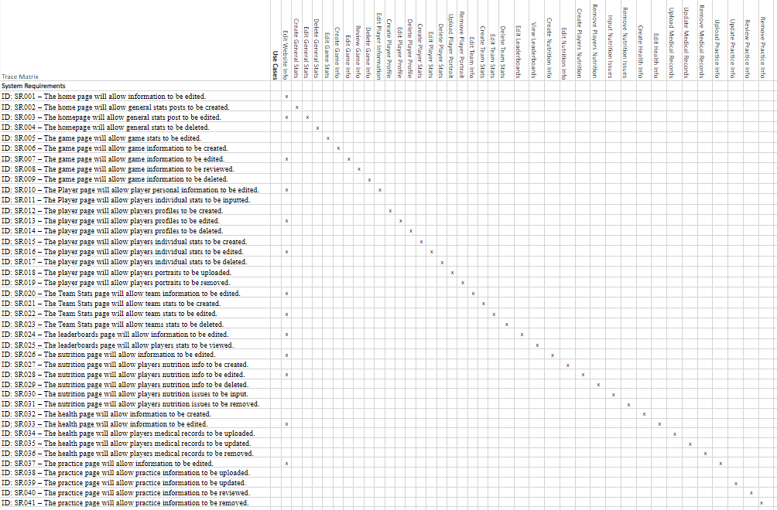

# Class Diagram

[Link to Class Diagram](https://cardmaillouisville.sharepoint.com/:u:/s/GroupA/EaOk5W2XoQ5CpQVkFtarlJ8BN9C9UDy_9_TIGqnYTxo0lg?e=GDIV4s)

# Database Diagram

[Link to Database Diagram](https://cardmaillouisville.sharepoint.com/:u:/s/GroupA/EaAA13Vz1dZJiNDHBGhvABMBO0tPji55LnSFNcVRzYwmMw?e=42tyHY)

# Database Definitions

**Administrator**

|  |  |  |  |  |
| --- | --- | --- | --- | --- |
| Attribute | Attribute Definition | Attribute Type | Attribute Size | Key |
| Admin ID | Unique identifier for Admin | Unsigned long | 4 bytes | Primary |
| Login Username | Admin username for UofL administration account | String | 255 bytes max | No |
| Login Password | Admin password for UofL administration account | String | 255 bytes max | No |
| First Name | Admin’s First Name | String | 255 bytes max | No |
| Last Name | Admin’s Last Name | String | 255 bytes max | No |

**Strength Coach**

|  |  |  |  |  |
| --- | --- | --- | --- | --- |
| Attribute | Attribute Definition | Attribute Type | Attribute Size | Key |
| Strength Coach ID | Unique identifier for strength coach | Unsigned long | 4 bytes | Primary |
| Login Username | Strength coach username for UofL administration account | String | 255 bytes max | No |
| Login Password | Strength coach password for UofL administration account | String | 255 bytes max | No |
| First Name | Strength coach First Name | String | 255 bytes max | No |
| Last Name | Strength coach Last Name | String | 255 bytes max | No |

**Health Specialist**

|  |  |  |  |  |
| --- | --- | --- | --- | --- |
| Attribute | Attribute Definition | Attribute Type | Attribute Size | Key |
| Health Specialist ID | Unique identifier for Health Specialist | Unsigned long | 4 bytes | Primary |
| Login Username | Health Specialist username for UofL administration account | String | 255 bytes max | No |
| Login Password | Health Specialist password for UofL administration account | String | 255 bytes max | No |
| First Name | Health Specialist First Name | String | 255 bytes max | No |
| Last Name | Health Specialist Last Name | String | 255 bytes max | No |

**Nutritionist**

|  |  |  |  |  |
| --- | --- | --- | --- | --- |
| Attribute | Attribute Definition | Attribute Type | Attribute Size | Key |
| Nutritionist ID | Unique identifier for Nutritionist | Unsigned long | 4 bytes | Primary |
| Login Username | Nutritionist username for UofL administration account | String | 255 bytes max | No |
| Login Password | Nutritionist password for UofL administration account | String | 255 bytes max | No |
| First Name | Nutritionist First Name | String | 255 bytes max | No |
| Last Name | Nutritionist Last Name | String | 255 bytes max | No |

**Player**

|  |  |  |  |  |
| --- | --- | --- | --- | --- |
| Attribute | Attribute Definition | Attribute Type | Attribute Size | Key |
| Player ID | Unique identifier for Player | Unsigned long | 4 bytes | Primary |
| Login Username | Player username for ULINK account | String | 255 bytes max | No |
| Login Password | Player password for ULINK account | String | 255 bytes max | No |
| First Name | Player First Name | String | 255 bytes max | No |
| Last Name | Player Last Name | String | 255 bytes max | No |

+

**General Stats**

|  |  |  |  |  |
| --- | --- | --- | --- | --- |
| Attribute | Attribute Definition | Attribute Type | Attribute Size | Key |
| Page ID | Unique identifier for the page | Unsigned long | 4 bytes | Primary |
| Total Points | The team's total points | Float | 4 bytes | No |
| Points Per Game | The team's average points per game | Float | 4 bytes | No |
| Scoring Margin | The Teams scoring margin | Float | 4 bytes | No |
| FG: Made-Attempted | Teams field goal made verses attempted | String | 255 bytes max | No |
| FG: Percentage | Teams field goal percentage | Float | 4 bytes | No |
| FG. Per Game | Teams average field goal points per game | Float | 4 bytes | No |
| 3PT: Per Game | Teams three-point shots per game | Float | 4 bytes | No |
| FT: Made-Attempted | Teams free throws made verses attempted | String | 255 bytes | No |
| FT: Percentage | Teams free throw percentage | Float | 4 bytes | No |
| FT: Per Game | Teams average free throws per a game | Float | 4 bytes | No |
| Rebound. Total | Teams total rebounds | Float | 4 bytes | No |
| Rebound. Per Game | Teams average rebounds per game | Float | 4 bytes | No |
| Rebound. Margin | Teams rebound margin | Float | 4 bytes | No |
| Assist. Total | Teams total number of assists | Float | 4 bytes | No |
| Assist. Per Game | Teams average assists per game | Float | 4 bytes | No |
| Turnover. Total | Teams total turnovers | Float | 4 bytes | No |

**Game Stats**

|  |  |  |  |  |
| --- | --- | --- | --- | --- |
| Attribute | Attribute Definition | Attribute Type | Attribute Size | Key |
| Page ID | Unique identifier for the page | Unsigned long | 4 bytes | Primary |
| Game ID | Unique identifier for the game | Unsigned long | 4 bytes | Primary |
| Opponent | The name of the opposing team | String | 255 bytes | No |
| Date | The date of the game | Date | 3 bytes | No |
| Score | Ending game score of both teams | String | 255 bytes | No |
| W/L | Signifying is the team won or lost the game | Char | 1 byte | No |
| FGM/A | The number of field goals made verses attempted | String | 255 bytes | No |
| Field Goal: PCT | Field goal performance percentile | Float | 4 bytes | No |
| 3FG/A | 3-point field goals made verses attempted | String | 255 bytes | No |
| 3-point: PCT | 3-point field goal performance percentile | Float | 4 bytes | No |
| FTM/A | Number of free throws made verses attempted | String | 255 bytes | No |
| Free-throw: PCT | Free throw performance percentile | Float | 4 bytes | No |
| OFF | Specific stats for a player on offense | Integer | 4 bytes | No |
| DEFF | Specific stats for a player on defense | Integer | 4 bytes | No |
| TOT | Specific stat that tells how many teams a player has played for | Integer | 4 bytes | No |
| AVG | Average of player’s stats both on offense and defense | Float | 4 bytes | No |
| PF | Specific stats about a foul a specific player have conducted | Integer | 4 bytes | No |
| AST | Specific stat to a player after helping a teammate score | Integer | 4 bytes | No |
| TO | Specific stat for each player has conducted a turnover | Integer | 4 bytes | No |
| BLK | Specific stat that shows a player blocking another | Integer | 4 bytes | No |
| STL | Specific stat per player for number of steals per player | Integer | 4 bytes | No |
| PTS | Specific stat per player for number of points score | Integer | 4 bytes | No |
| AVG | Average between total points per player | Float | 4 bytes | No |

**Team Stats Page**

|  |  |  |  |  |
| --- | --- | --- | --- | --- |
| Attribute | Attribute Definition | Attribute Type | Attribute Size | Key |
| Page ID | Unique identifier for the page | Unsigned long | 4 bytes | Primary |
| Team ID | Unique Identifier for each team | Unsigned long | 4 bytes | Primary |
| Section Header | A header that separates the stats into related groups. | String | 255 Bytes | No |
| Total Points | The total points scored during the specified timeframe | Unsigned long | 4 bytes | No |
| Points Per Game | Average points per game during the specified timeframe | Unsigned long | 4 bytes | No |
| Scoring Margin | UofL points per game minus the opponents points per game | Double | 8 bytes | No |
| FG: Made-Attempted | The field goals made and attempted respectively, separated by a dash | String | 255 bytes | No |
| FG: Percentage | Field goals made divided by field goals attempted | Double | 8 bytes | No |
| FG: Per Game | Average field goals per game | Double | 8 bytes | No |
| 3PT: Made-Attempted | The three pointers made and attempted respectively, separated by a dash | String | 255 bytes | No |
| 3PT: Percentage | Three pointers made divided by the three pointers attempted | Double | 8 bytes | No |
| 3PT: Per Game | Average three pointers per game | Double | 8 Bytes | No |
| FT: Made-Attempted | The free throws made and attempted respectively, separated by a dash | String | 255 bytes | No |
| FT: Percentage | The free throws made divided by the free throws attempted | Double | 8 bytes | No |
| FT: Per Game | Average free throws per game | Double | 8 bytes | No |
| Total Rebounds | The total number of rebounds | Unsigned long | 4 bytes | No |
| Rebounds Per Game | The average rebounds per game | Double | 8 bytes | No |
| Rebound Margin | UofL rebounds per game minus the opponent’s rebounds per game | Double | 8 bytes | No |
| Total Assists | The total number of assists | Unsigned long | 4 bytes | No |
| Assists Per Game | The average number of assists | Double | 8 bytes | No |
| Total Turnovers | The total number of turnovers | Unsigned long | 4 bytes | No |
| Turnovers Per Game | The average turnovers per game | Double | 8 bytes | No |
| Turnover Margin | UofL turnovers per game minus the opponent's turnovers per game | Double | 8 bytes | No |

**Leaderboard**

|  |  |  |  |  |
| --- | --- | --- | --- | --- |
| Attribute | Attribute Definition | Attribute Type | Attribute Size | Key |
| Page ID | Unique identifier for the page | Unsigned long | 4 bytes | Primary |
| Player ID | Unique identifier for each player | Unsigned long | 4 bytes | Foreign |
| Team ID | Unique identifier for each team | Unsigned long | 4 bytes | Foreign |
| Score | Ending game score of both teams | String | 255 bytes | No |
| Team Ranking | Each team’s rank based off current team's record | Float | 4 bytes | No |
| Player Ranking | Each player’s rank based off player’s stats | Float | 4 bytes | No |

**Nutrition**

|  |  |  |  |  |
| --- | --- | --- | --- | --- |
| Attribute | Attribute Definition | Attribute Type | Attribute Size | Key |
| Page ID | Unique identifier for the page | Unsigned long | 4 bytes | Primary |
| Nutritionist ID | Unique identifier for Nutritionist | Unsigned long | 4 bytes | Foreign |
| Player ID | Unique identifier for each player | Unsigned long | 4 bytes | Foreign |
| Players Nutrition | Each players current nutrition | String | 255 bytes | No |
| Nutrition Requirements | Specific minimum requirements for nutrition provided to each player | String | 255 bytes | No |
| Nutrition Goals | Specific goals set for each player for nutrition | String | 255 bytes | No |
| Nutrition Restrictions | Specific restrictions for each player in nutrition | String | 255 bytes | No |

**Health**

|  |  |  |  |  |
| --- | --- | --- | --- | --- |
| Attribute | Attribute Definition | Attribute Type | Attribute Size | Key |
| Page ID | Unique identifier for the page | Unsigned long | 4 bytes | Primary |
| Health Specialist ID | Unique identifier for Health specialist | Unsigned long | 4 bytes | Foreign |
| Player ID | Unique identifier for each player | Unsigned long | 4 bytes | Foreign |
| Players Health | Each players current health status | String | 255 bytes | No |
| Medical History | Each players medical history | String | 255 bytes | No |
| Injuries | Each players information for injuries | String | 255 bytes | No |
| Illness | Each player information for any illness | String | 255 bytes | No |
| Medication | Medications player are currently using | String | 255 bytes | No |
| Treatment | Documentation of treatment plan | String | 255 bytes | No |

**Practice**

|  |  |  |  |  |
| --- | --- | --- | --- | --- |
| Attribute | Attribute Definition | Attribute Type | Attribute Size | Key |
| Page ID | Unique identifier for the page | Unsigned long | 4 bytes | Primary |
| Player ID | Unique identifier for each player | Unsigned long | 4 bytes | Foreign |
| Date | Practice Date | Date | 3 bytes | No |
| Time | Practice Time | Time | 3 bytes | No |
| Jump Height | Jump height in mm calculated | String | 255 bytes | No |
| System Weight | Data from Force Plate system | String | 255 bytes | No |
| Player Load Band | Data from Catapult system | String | 255 bytes | No |
| PTS | Points from practice game box | Integer | 4 bytes | No |
| REBS | Rebounds from practice game box | Integer | 4 bytes | No |
| ASSISTS | Assists from practice game box. | Integer | 4 bytes | No |
| STEALS | Steals from practice game box. | Integer | 4 bytes | No |
| BLOCKS | Blocks from practice game box | Integer | 4 bytes | No |
| 2 PTM | 2 Point shots made from practice game box. | String | 255 bytes | No |
| 2 PTA | 2 Point shots attempted from practice game box. | Double | 8 bytes | No |
| 2 PT% | Average 2-point shots from practice game box | Double | 8 Bytes | No |
| 3 PTM | 3 Point shots made from practice game box | String | 255 bytes | No |
| 3 PTA | 3 Point shots attempted from practice game box. | Double | 8 bytes | No |
| 3 PT% | Average 3-point shots from practice game box | Double | 8 Bytes | No |
| FGM | Field goals made from practice game box | String | 255 bytes | No |
| FGA | Field goals attempted from practice game box. | Double | 8 bytes | No |
| FG% | Average field goals from practice game box | Double | 8 Bytes | No |
| FTM | Free throws made from practice game box | String | 255 bytes | No |
| FTA | Free throws attempted from practice game box. | Double | 8 bytes | No |
| FT % | Average free throws from practice game box | Double | 8 Bytes | No |
| TO | Turnovers from practice game box | Integer | 4 bytes | No |

**Player Information**

|  |  |  |  |  |
| --- | --- | --- | --- | --- |
| Attribute | Attribute Definition | Attribute Type | Attribute Size | Key |
| Page ID | Unique identifier for the page | Unsigned long | 4 bytes | Primary |
| Player ID | Unique identifier for each player | Unsigned long | 4 bytes | Foreign |
| Player Portrait | A picture of the player | Image |  | No |
| Player First Name | Players first name | String | 255 bytes | No |
| Player Last Name | Players last name | String | 255 bytes | No |
| Player Number | Player jersey number | String | 255 bytes | No |
| Player Position | Player position | String | 255 bytes | No |
| Player Class | Player’s current class | String | 255 bytes | No |
| Player High school | Players’ high school | String | 255 bytes | No |
| Player Hometown | Players’ hometown | String | 255 bytes | No |

**Player Statistics**

|  |  |  |  |  |
| --- | --- | --- | --- | --- |
| Attribute | Attribute Definition | Attribute Type | Attribute Size | Key |
| Page ID | Unique identifier for the page | Unsigned long | 4 bytes | Primary |
| Player ID | Unique identifier for each player | Unsigned long | 4 bytes | Foreign |
| FGM/A | The number of field goals made verses attempted | String | 255 bytes | No |
| FGM/A PCT | Field goal performance percentile | Float | 4 bytes | No |
| 3FGM/A | 3-point field goals made verses attempted | String | 255 bytes | No |
| 3FGM/A PCT | 3-point field goal performance percentile | Float | 4 bytes | No |
| FTM/A | Number of free throws made verses attempted | String | 255 bytes | No |
| FTM/A PCT | Free throw performance percentile | Float | 4 bytes | No |
| OFF | Points produced by player  possessions | Integer | 4 bytes | No |
| DEF | Points defended against | Integer | 4 bytes | No |
| AVG | Average points within game | Float | 4 bytes | No |
| PF | Personal fouls received | Integer | 4 bytes | No |
| AST | Amount of total contribution to teams score | Float | 4 bytes | No |
| TO | Number of turnovers during session | Integer | 4 bytes | No |

# User Interface Navigation Diagram and Screen Layouts

**Sign in Page**

When accessing website, the first page will require login credentials to access any data. Sign in button will redirect the user to the dashboard if correct credentials are entered.

**Dashboard**

After signing in, Users will be able to select one of the three categories, Player Health, Player Statistics and Team administration. Selecting any of these icons will redirect user to the respected screen.

**Player Statistics Dashboard**

Player Statistics displays all active team members with their position, class, height, and weight. Selecting an Icon for a player will bring the user to the player statistics page for them.

**Statistics**

Player Statistics will allow users to select, edit or remove practice records, performance records, DARI, Force and Perch information onto a user account. Records will be held in table format to keep uniform presentation unless specified otherwise.

**Player Health Dashboard**

The player health dashboard mirrors the player statistics dashboard within the same layout. It displays the position, class, height, and weight of players.

**Player Health**

The player health dashboard will allow medical documents and nutritional data to be added within the players profile. Selecting the plus icon will allow a new column to be added to the user field and select the trash icon will delete the records.

**Team Administration**

The Team administration page will show four categories: Report Maintenance, Player Maintenance, User Maintenance, and Team Maintenance. Selecting these icons will redirect to the respective table to edit and make changes to database of users, players, or reports.

# Gantt Chart

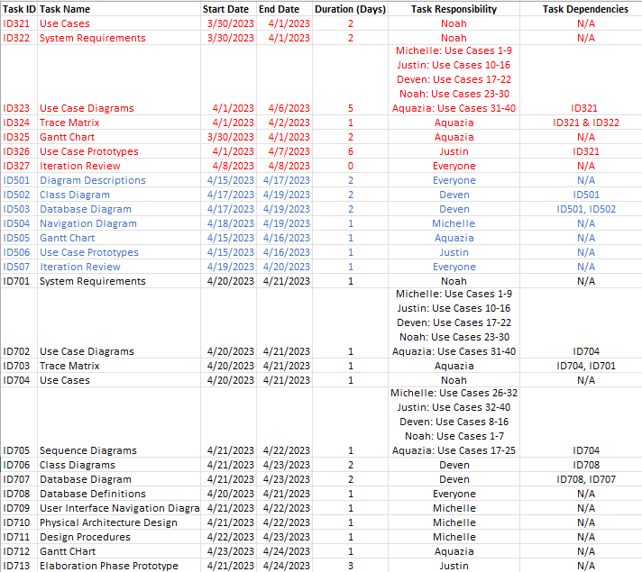

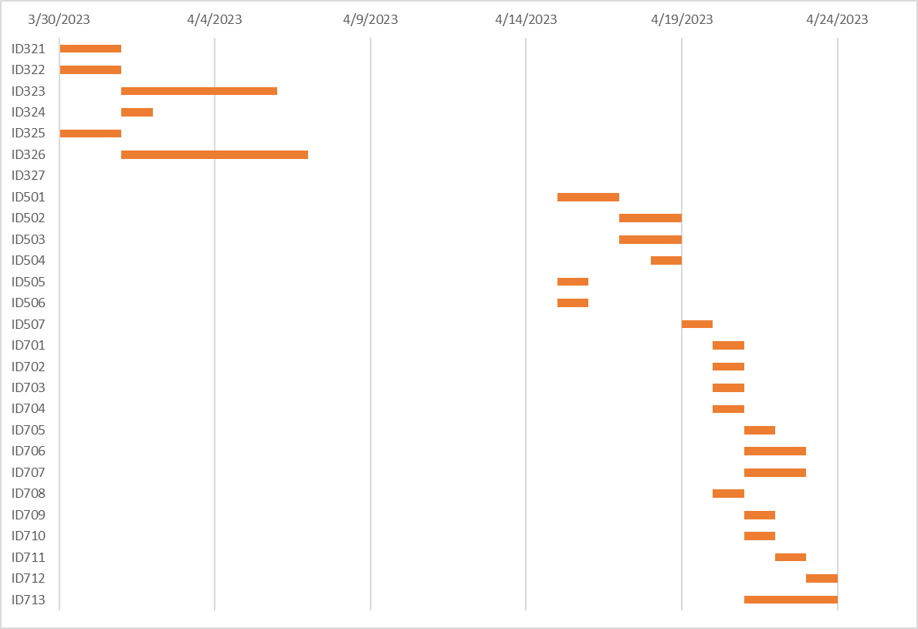

# Physical Architecture Design

The physical architecture design shows how to access the website and Microsoft Access application from the administration, nutritionist, coaches, and medical staffs prospective. The three workstations represent an amalgamation of all then staff access information to view or enter and the administration alone are the communications between the databases and the server. Any staff may access anything through their personal laptop to access the Microsoft Access or the UofL Men’s Basketball Server. All computers use a WAN (wide area network) to connect to server or Microsoft Access so that information can be accessed during travel. Administration is the only set of people that have direct connection to the databases to effectively run the website. run the website.

# Design Procedures for Security Concerns and Non-Functional Requirements

The important procedures to be implemented for nonfunctional requirements include:

* Creating a website with a paid WordPress account
* Automated backup through WordPress
* Secure access using login.
* Integration of WordPress and Microsoft Access
* Being able to view and manage data throughout the website.

This system is mainly kept secure by the Login function through both WordPress and Microsoft Access. Using the paid version of WordPress allows for database integration. The paid version also includes backup and 24/7 technical assistance. Microsoft Access acts as a second back for uploaded spreadsheets and can be integrated with the WordPress database as well. Using Microsoft Access also must be verified though login and is secure down to the record level. Typing in accurate credential will only allow you to access specific information such as a players’ health or practice information.

It is also important that the information is constantly up to date and correct which is the job of the internship based IT along with the aid of the administration and other staff to point out issues. The WordPress website is to be created first and then the Microsoft Access database to upload existing information.

# Elaboration Phase Prototypes

**Use Case 2:** Create General Stats, **Use Case 3:** Edit General Stats, **Use Case 4:** Delete General Stats.

**Use Case 5:** Edit Game Stats, **Use Case 6:** Create Game Info, **Use Case 7:** Edit Game Info, **Use Case 8:** Review Game Info, **Use Case 9:** Delete Game Info.

**Use Case 10:** Edit Player Information, **Use Case 11:** Create Player Profile, **Use Case 12:** Edit Player Profile, **Use Case 13:** Delete Player Profile.

**Use Case 14:** Create Player Stats, **Use Case 15:** Edit Player Stats, **Use Case 16:** Delete Player Stats.

**Use Case 17:** Upload Player Portrait, **Use Case 18:** Remove Player Portrait.

**Use Case 19:** Edit Team Info, **Use Case 20:** Create Team Stats, **Use Case 21:** Edit Team Stats, **Use Case 22:** Delete Team Stats.

**Use Case 23:** Edit Leaderboards, **Use Case 24:** View Leaderboards.

**Use Case 25:** Create Nutrition Info, Use **Case 26:** Create Players Nutrition, **Use Case 27:** Edit Players Nutrition, **Use Case 28:** Remove Players Nutrition, **Use Case 29:** Input Nutrition Issues, Use **Case 30:** Remove Nutrition Issues.

**Use Case 31:** Create Health Info, **Use Case 32:** Edit Health Info

**Use Case 33:** Upload Medical Records, Use **Case 34:** Update Medical Records, Use **Case 35:** Remove Medical Records.

**Use Case 36:** Upload Practice Info, Use **Case 37:** Update Practice Info, **Use Case 38:** Review Practice Info, **Use Case 39:** Remove Practice Info.

